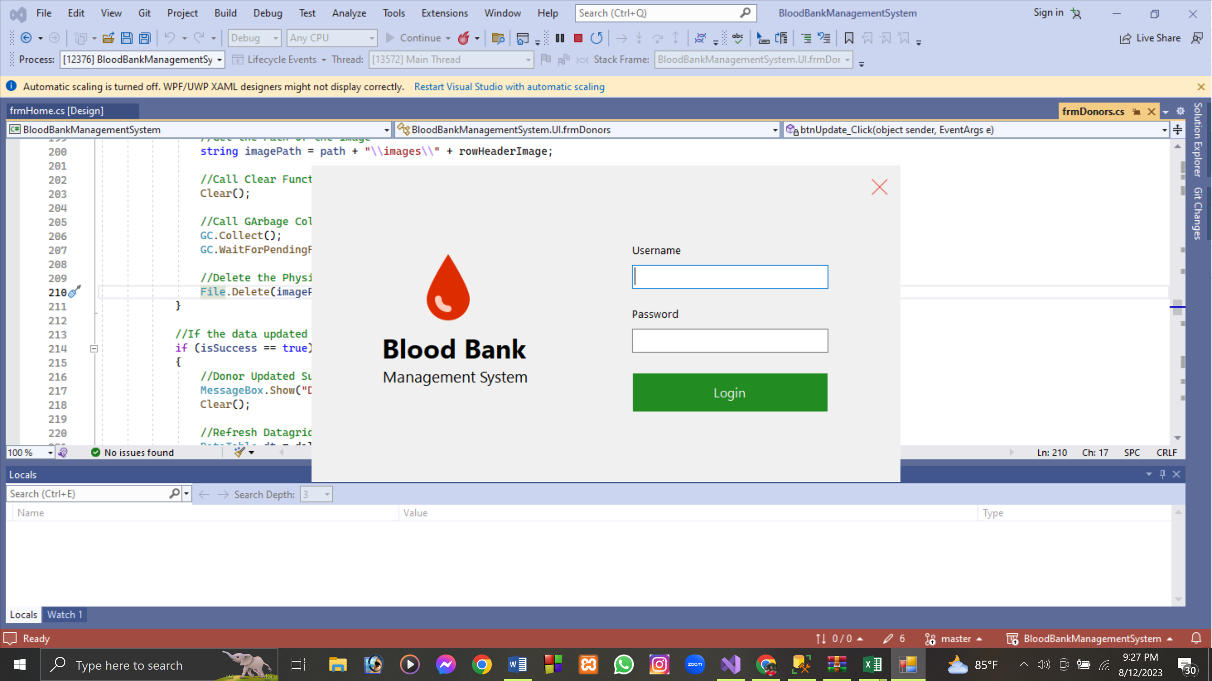

User Interface:

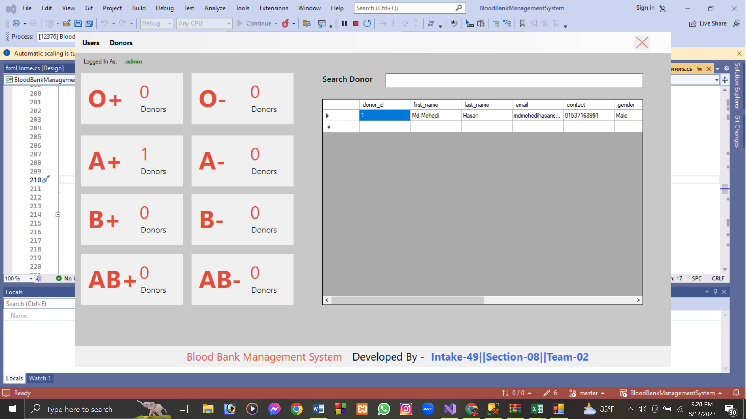

Click on Users:

New Pop-Up window

Here you can add,update,delete User.

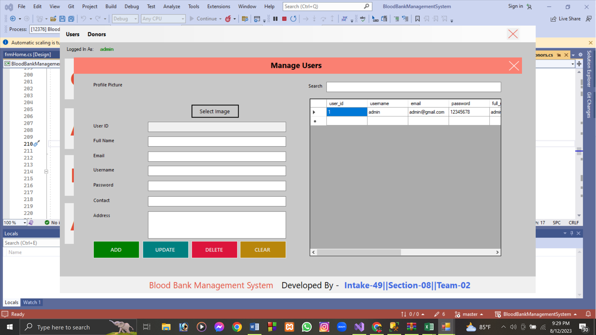

Click on Donors:

New Pop-Up window

Here you can add,update,delete User.

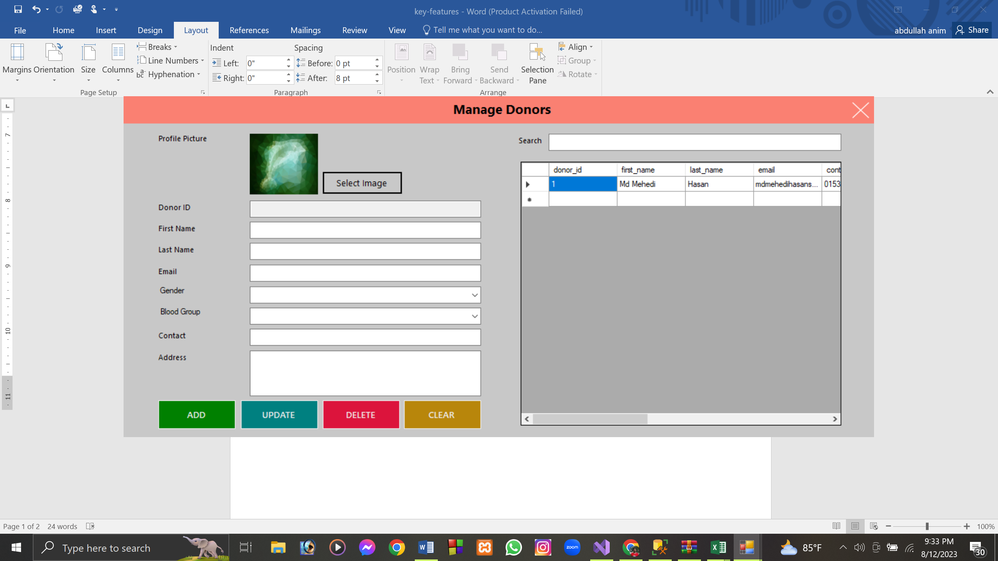

Clicking there automatically data will fillup if exist.

